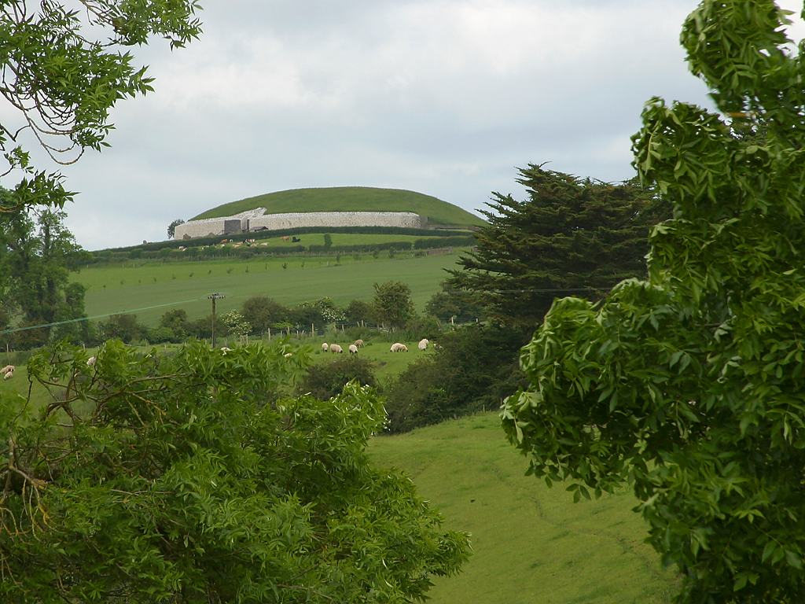 | Newgrange, located 40km north of Dublin and perched high above a bend of the River Boyne, is a prehistoric passage tomb, covered on the outside by a large grassy mound. At over 5,000 years old it is the older cousin of Stonehenge and it predates the pyramids by about 500 years.  Newgrange is unique because the builders aligned it with the rising sun. Just after sunrise, at 0858GMT, on the shortest day of the year, 21 December, St. Stephen’s Day, the inner chamber is designed to flood with sunlight, which enters through a 25cm (9.9ins) high "roof box" above the passage entrance.  The solstice phenomenon was discovered by archaeologist, Professor Michael J O'Kelly on 21 December 1967 during research on the site. "He found the roof box when uncovering the roof chamber but wondered about its purpose," says his daughter Helen Watanabe O'Kelly. Local people always said it was aligned to the sun but the measurements did not fit the summer solstice.  "My mother, who worked closely with him, suggested that it might be connected with the winter solstice. And that was how he discovered it in 1967." Ms O'Kelly recalls how she experienced it with him the following year.  "There were just the two of us. It was cold and dark - no razzmatazz, like you have now. I still remember sitting in the cold and we just waited. Even though the passage way and chamber are only 24m (78ft) long, once you enter you are cut off from the outside world and lose a sense of time passing. We have to wait four minutes after sunrise to experience the light entering the chamber because the earth's angle has changed since it was constructed 5,000 years ago. Suddenly this shaft of light came into the chamber and hit the back wall. I remember being quietly moved - it was like someone was speaking to you from thousands of years before. I still see it like a picture before my inner eye - it was a golden light.”  The light remains in the chamber for seventeen minutes before retreating.
The way to Newgrange
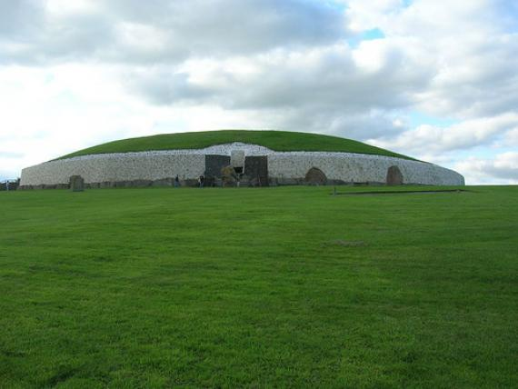
The wall of white stones
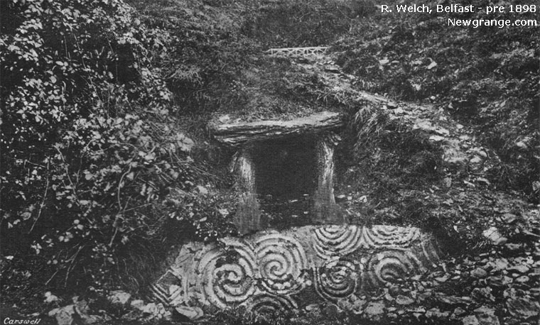  The entrance rediscovered | 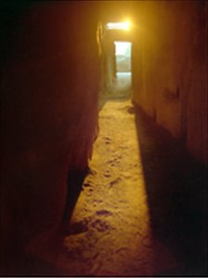 | 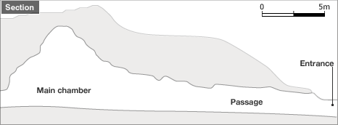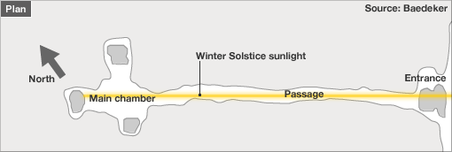
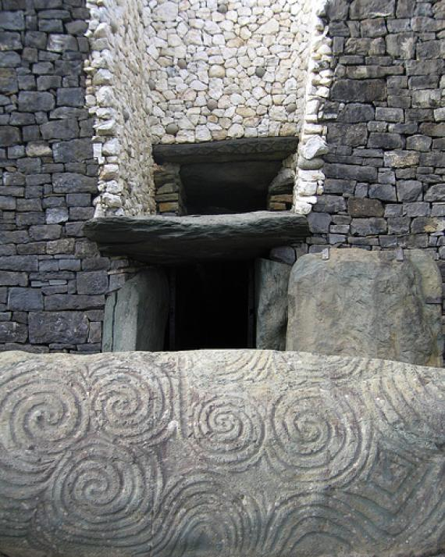
The entrance today with roofbox | 17 magical minutes on St. Stephen’s Day

Chapter One

Bridget looks at the scroll the giants gave to her. Unfurled it is as big as Bridget’s bed-sheets at home. The lower half has huge, scrawling signatures. Across the top, in letters as large as Bridget’s head, it says ‘Certified Treasure Hunter’. ‘I am NOT a dwarf’ celebrates Bridget silently. Although, truth be told, her neck hurts from looking up at the forest of giants around her. ‘I am on this green island of giants for treasure. For Nogard’s fabulous treasure. I am a treasure-hunter’.

Although themselves terrified of Nogard, the village of giants at the base of Nogard’s mountain do not let just anyone attempt to retrieve Nogard’s treasure. But Bridget has charmed the villagers with her personality and passed their tests and challenges, and the giants have opened the gate that leads to the road, that leads to the mountain, that lead to the passageway, that leads to Nogard’s treasure. Rolling up the scroll into a staff and tying up all her goods from home in a red-spotted handkerchief, Bridget sets off.

It’s a long, long road, but Bridget’s passion and persistence and pig-headedness keep her going. She reflects on what the giants have told her: ‘The passage-way is full of traps!’, ‘And always dark!’, ‘You can’t see the deep pits in the floor!’, ‘You won’t see the swinging blades’. ‘In the dark you’ll die for sure!’, ‘Ah! But, there is St. Stephen’s day!’, ‘But Nogard never sleeps on St. Stephen’s day!’, ‘Anyone in that passageway on St. Stephen’s day will be eaten alive – to be sure’. ‘St. Stephen’s Day?’ questioned Bridget. ‘Yes, St Stephen’s day – the one day of the year when the sun, streaks like an arrow down that passageway and for seventeen minutes a rainbow of light streams out filling the valley below with colours’. ‘Wow!’ thought Bridget.

Now, up ahead, Bridget can see a wall of white stones above and around the black, jet black, dead black, blacker than black entrance to the narrow passageway.

St. Stephen’s Day is the day after tomorrow.

Chapter Two

The village square is ablaze with colours. In the middle of the green Bridget has uncrumpled her scroll to reveal an enormous pile of jewels of every type: red rubies, green emeralds, blue sapphires – in fact every colour of the rainbow. The giants are all goggle-eyed. And bursting with every type of question. ‘How many dead treasure-hunters did you see? ‘Was Nogard asleep? Did you kill Nogard? Is there anymore treasure?’ Again, and again they repeat one question. ‘How did you do it?’

After much begging and cajoling from the villagers, Bridget eventually concedes. She points to the red-spotted handkerchief. ‘I used a tool that I brought from home’. ‘What? What?’ scream all the giants. Bridget unties the handkerchief, takes out her lip salve and, peering into her make-up case, daubs her lips. ‘There!’ ‘You see?’. ‘See what?’ puzzle the giants. ‘Look!’ says Bridget. The giants look at Bridget’s lips and see nothing. Well, truthfully they saw lips. And are getting annoyed. And looking avariciously at that huge pile of treasure that Bridget will soon wrap up and take away. ‘But I don’t understand!’ wailed one of the children.

Bridget is kind. Into the child’s hand she places one of the rubies (one of the smallest. She’s not THAT kind!), and picks up the make up case. Suddenly a beam of red light shines up into the child’s face – which beams too.

‘Aha!’ yells the child. ‘I get it! I get it! I get it!’. ‘The mirror! The mirror!’ ‘You made St. Stephen’s Day come early!’

Chapter Three

Nogard is dead: his treasure is long gone. So how can you know that this story is true? Well, Nogard may be gone. But his lair is still there. And you can shudder there. You can see the wall of white stones. You can enter that cold, silent, dark, dark passageway, dark as the darkest night. You can smell the ancient dust. You can feel the hard floor where Nogard slept on a sea of harder pebbles. And yes, even if it is not St. Stephen’s Day, you can light up the path to treasure - all the way to the end - with just a mirror, held for others.

I know that you can do it, because I already have!

